Q3 Science/Social Studies PROJECT BOARD
Animal Needs  Create a mythical animal combining 2 different animals of your choosing (Lion + Tiger = Liger, etc.).  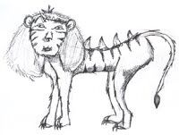  Draw your animal on a poster and show the various needs it requires to survive (Food, Water, Shelter). | Continents & Oceans  Use Playdoh to create a map of the world showing the Oceans & Continents.  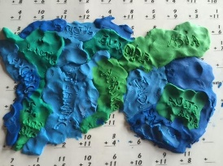  Don’t forget to label it! | Lewis & Clark Expedition # 1  Create a journal out of paper & go on an expedition like Lewis & Clark did! Go to the park or the backyard and draw/label the things you see in the journal.  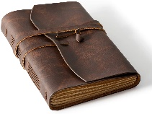
Create a landform Diorama!  Click on the link to learn more about how to create one.  https://www.youtube.com/watch?v=MuIH1yrZz0U  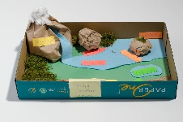  List of possible landforms: Ocean, Plateau, Island, Mountain, Plain.  To learn more, click on the link below: https://www.youtube.com/watch?v=QLhKCr_qTJU | FREE SPACE  Come up with your own idea for a project about animals!  Examples: PowerPoint, iMovie, painting/drawing, flip book, foldable, etc. | Write a song or rap about the Continents & Oceans. Record yourself and post it on Seesaw!
Theodore Roosevelt- The conservationist  Roosevelt cared about the environment and helped to create many National Parks around the United States!  Watch the video below to see the various parks in the U.S.  https://www.youtube.com/watch?v=lva1m8cl9-Q  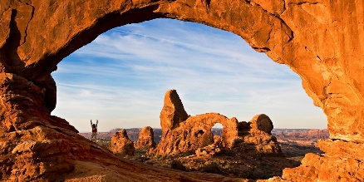  Pick your FAVORITE park, and create a brochure trying to CONVINCE people to come visit! Make sure to give a lot of reasons! | Lewis & Clark Expedition #2  Go on an adventure to a new place you have never been before (a new park, the zoo, the mall, etc.).  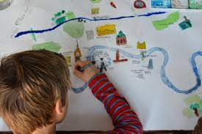  Use a poster board and draw a map of the place you visited, including pictures of the important landmarks and labels. | Sacagawea  Watch the video below about Sacagawea:  https://www.youtube.com/watch?v=FDb-3TnKmXg  Create a comic strip showing your favorite part of Sacagawea’s story!  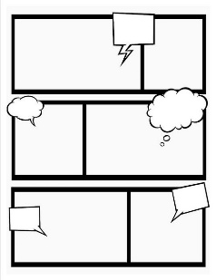

Note: Many of these projects require parental guidance as they require the use of materials that may not be safe for students to use on their own.

